**Final Project Design**

**Introduction**

The final design of the kitchen waste energy harvester will convert ambient heat and motion into electrical energy. The energy will be harvested through a thermoelectric generator and piezoelectric generator. The device will store this energy in a rechargeable Li-ion battery so that it can be used later on in other small appliances, like the rice cooker. The generators are capable of taking waste energy from stove tops, blenders, and dishwashers. To enable simple user interface, an Arduino Uno is used to control a touch screen on the front face and an automatic shut-off mechanism once the battery is filled. The device was designed with convenience in mind, and represents an efficient solution to energy harvesting within a kitchen. The design fails to meet a few of the requirements, but this is solely due to insufficient research before forming the requirements, which resulted in unreasonable expectations.

**Description**

This energy harvester is meant to serve as a tabletop appliance, which is small enough to be easily stowed away when necessary. Its main purpose is to capture energy in the kitchen that would otherwise be wasted and then use that to power other appliances. This device mainly relies on the heat energy given off immediately after stovetop use and the vibrational energy available during the use of another appliance, like a blender or mixer. For proper use on a stove, the user would simply unwind the cord of the thermoelectric generator pad and place it directly onto the hot surface, covering as much area as possible. This could be left on the stove for as long as desired, although after about 30 minutes the energy obtained is minimal. As for the mechanical energy aspect, the user would just place the piezoelectric generator pad underneath the blender, in a position with maximum contact. As the blender is being used, the vibrational motion will be converted by the generator pad. When the pads are done collecting energy, the cords can be wrapped up around hooks on the back of the device and the pads can be stowed away in a slot on the bottom of the device. Once enough energy has been collected and stored, the user can plug a rice cooker into one of the outlets on the side to successfully power it.

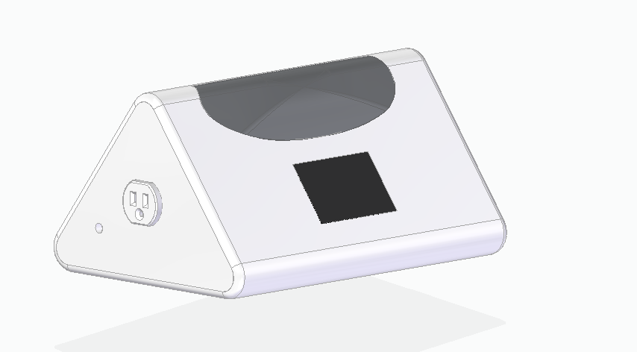 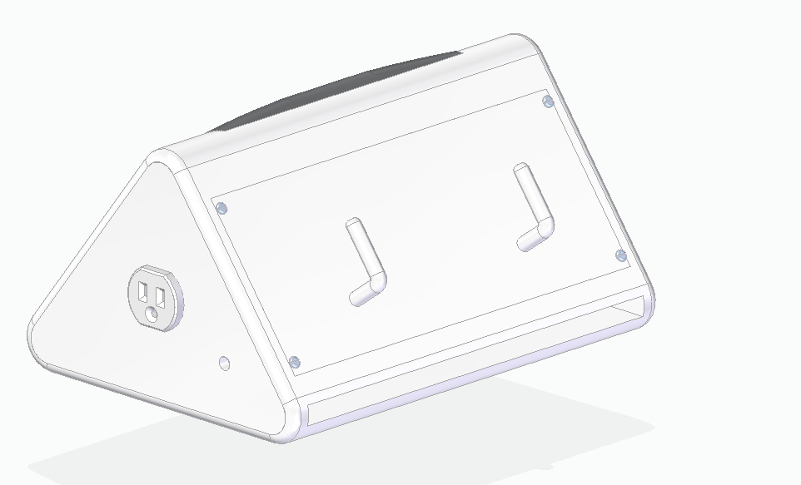

*Figure 1*: Solid Edge Model of the Device

The main body of the device will be constructed out of white and grey ABS polycarbonate to make it durable and heat resistant, yet sleek (Custom materials for home appliances, 2017). The maximum dimensions will be 8.457 x 6.225 x 12.5 in3, which allows all of the internal components to fit inside. The wires for the generator pads will extend from the sides of the device. The wires are going to be 3 feet long which allows the user to leave the device in one place while collecting energy from elsewhere in the kitchen. Additionally, in Figure 1 it can be seen that the back of the device includes two hooks and a narrow compartment, which facilitates convenient storage. The user is able to wrap the long cords around the hooks and place the pads inside the slot to keep the device nice and neat.

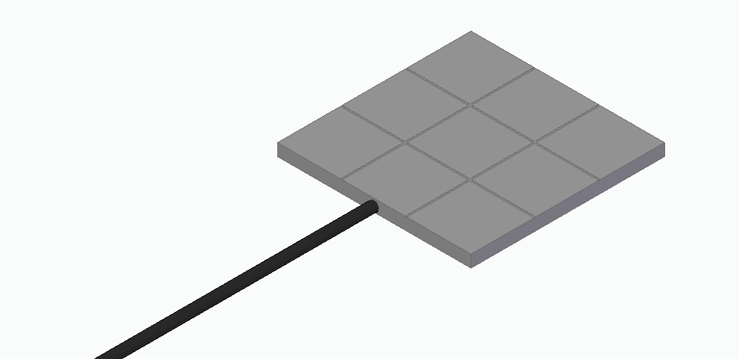

*Figure 2*: Solid Edge Model of the Thermoelectric Generator Pad

The thermoelectric generator (TEG) pad is composed of nine thermoelectric modules, which are manufactured by Thermal Electronics Co. They are made of bismuth telluride and lead telluride, allowing them to have superior efficiency and high temperature stability to withstand an electric stove (MODULE TEG1-PB-12611-6.0, 2018). The wires are also coated in teflon to prevent any damage from heat exposure. Accounting for the amount of surface area that will overlap between the stovetop and the TEG pad, it should be able to harvest about 26.5Wh or 2.21Ah at 12V. This is only over the course of one thirty minute session immediately following stove use. With this in mind, the TEG collects about 4.42 Ah of energy for every hour it is undergoing active use.

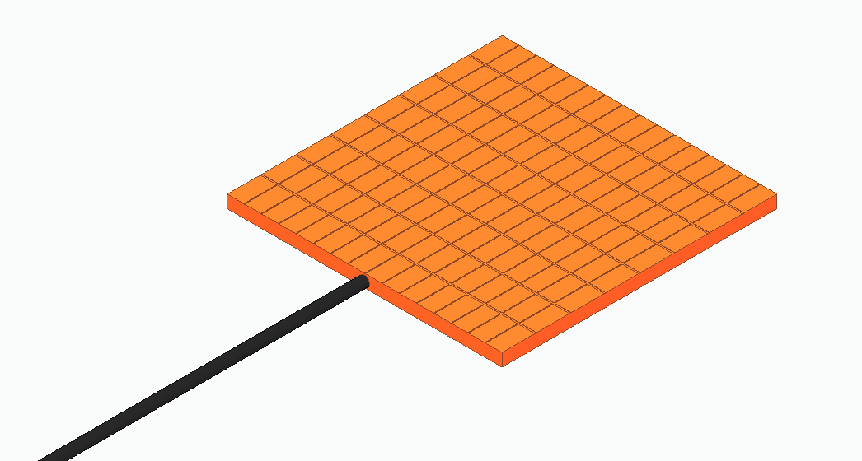

*Figure 3*: Solid Edge Model of the Piezoelectric Generator Pad

The piezoelectric generator (PEG) pad will be made up of one hundred twenty-eight piezoelectric composites (Ryu et al., 2015). The pad will be 22.4 cm2. Most blenders generally cover an area of 20 cm2 therefore the 22.4 cm2 is an efficient amount of space to harvest the vibrational energy from any blender. The PEG pad is simply laminated to maximize energy harvesting, it will not be heat resistant because it does not have to come in contact with the high temperature devices in the kitchen (Ryu et al., 2015). At peak performance, with all one hundred twenty-eight composites in use, the PEG pad is capable of supplying 23 Ah of energy to the battery if used for one hour (Ryu et al., 2015).

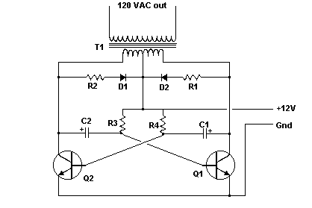

*Figure 4*: 12v DC to 120v AC Inverter Circuit Diagram

(Agarwal, 2018)

The energy that is collected by the generators will be stored within a rechargeable Li-ion battery housed inside the main body of the device. The particular battery being used in the design is a 12V 25Ah battery purchased from Shenzhen Tirib New Energy Technology. It’s dimensions are 8.8 x 4.5 x 2.8 in3 and it has a weight of about 6 lbs, which is much lighter and higher in energy density than other types of batteries (Anuphappharadorn et al., 2014). The actual capacity of the battery translates into being able to store about 300Wh of energy. If we were to assume a typical 350W rice cooker were being powered by the energy harvester, then it could run for about fifty one minutes, which is more than the ten to fifteen minutes needed to cook the rice. In order to successfully power the rice cooker, the 12V direct current source must somehow be converted into the necessary 120V alternating current for appliances. This was achieved by incorporating inverter circuitry between the battery and the outlets. Circuitry similar to what is proposed in the design can be seen in Figure 4. It includes an oscillator and a transformer, which converts the battery’s direct current into an oscillating square wave and then steps up the voltage to the required 120V. To achieve the 350W or more, the values of the circuit components would have to be adjusted, likely with more powerful transistors and transformers (Agarwal, 2018).

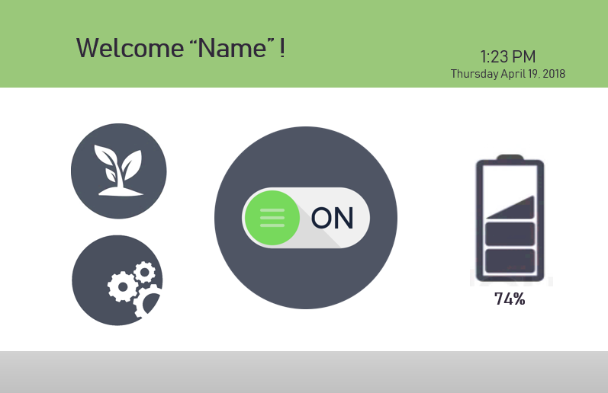

*Figure 5*: Touch screen display

The device features a 3.5 inch touch screen from Crystalfontz America, Inc., which allows the user to access the capabilities with ease. A representation of what the touch screen would look like can be seen in Figure 5. The screen has two main functions, but has creative elements as well. It’s important that the screen displays the remaining energy stored within the harvester so that they know when enough energy is present to power a device. This is achieved through the battery icon, which appear full and display “100%” when the battery completely charged. The screen also shows an on/off button in the center which indicates when the battery is charging. If the user wants to manually turn on or off the charging ability they can tap the button. It will also show them when the automatic shut-off has occurred. Additional highlights include the ability to select a name, time zone, and color scheme in the settings. The plant icon takes the viewer to information about how much energy has been saved over the course of the device’s use. To avoid wasting energy, after one minute of no activity, the display will enter a sleep mode, which it can be woken from by tapping the screen.

The percentage of battery capacity remaining, which is displayed on the screen, requires a mechanism to measure it. For this, the Arduino is connected to a LiPo fuel gauge electrical component, which can be purchased from SparkFun. It is connected in parallel to avoid interfering in the other circuitry present. The fuel gauge measures the relative state of charge on the battery, and the programmed Arduino would then send this value to the screen to be displayed.

For the manual shut off capability, a mechanical switch that is operated by a servo motor was included. When the user presses the power button on the screen, the programmed Arduino will signal for a servo motor to move. The movement of the servo will break the connection of a battery terminal, effectively ending the charging of the battery.Similarly, the user can press this same button to establish a connection and once again resume energy harvesting. The device’s battery also includes a protection circuit module (PCM) that will automatically disrupt charging when the battery gets full. This prevents overcharging of the battery and improves safety of the device (Kutcheck, 2017).

**Conclusion**

This final design effectively utilizes thermoelectric and piezoelectric generators to satisfy the needs of a consumer. With the touch screen capabilities and automatic shut-off mechanisms, the device is safe, convenient, and easy to operate. The device fulfills most but not all of the requirements, but this is due to unreasonable requirements being set in the beginning. The energy requirements conflicted with the weight requirements, and they were unattainable expectations for the purpose of the project. However, this design still achieves sufficient energy storage and a manageable weight despite slightly exceeding the requirements.